Stewart Dunn 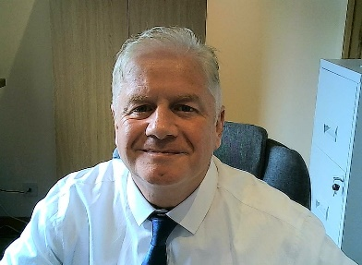

|  |  |
| --- | --- |
| Personal  Profile Summary | **A seasoned and passionate engineer, motivator and commercially astute business leader who combines careful contract negotiations and commercial skill to deliver complex, high-value projects on time, on budget every time. Uses a well-structured, common-sense and results driven approach.** |
| Career  History  Self Employed  **Flex**  **13 Years**  Career  History  **Solectron**  8 Years | November 2007 – Date  **Director of Product Development**  Presently based in Glasgow. Contracting with Flex.  Very active in Programme Management within diverse markets such as Smart Living / Connected Intelligence; Industrial, Audio, Medical and Automotive spaces, driving new Product Development of varied complexity and duration.  Hands-on coordinating Design functions – **software, hardware and mechanical design**; Supply Chain; NPI and launch into mass production. Pre COVID-19, much of my time was spent travelling to Asia, the US and Europe. I firmly believe in building long term relationships and making sure all my customers find it easy to do business and succeed in their plans.    **Recent achievements**   * Turnkey product design for Amazon, EE & ME Design in Sweden, launching into production ramp in Mexico now (Aug 2020). Customer delighted, field trials running brilliantly only one dropout from 2000 units deployed. * Highly successful design and launch of Multi-radio Gateway for Leroy Merlin. **Full Software stack development**, hardware and ME design. * Successful Global Account Manager for Soneter (later RWC) over a 4-year period, 2014-18. Product design out of Atlanta and production launch in China. * Flipped loss of Set Top Box business worth $500M with a major account. Re-designed the product to create multi $M savings for the customer. Slashed >$16 from a $160 product. * Enjoyed a highly successful two-year assignment as Operations Manager to develop local Op’s Management in Timisoara, Romania. * Drove the installation of eight full SMT & BB manufacturing and test lines. Ramped to **1M boxes in the first year**. Six-Sigma / LEAN manufacturing to continuously improve line balance, throughput and yields. Hugely reduced material holding and **95%** First time Pass achieved with a strict line set-up and validation procedure. * Femtocell redesign program translated into a **50% BOM cost reduction**.   June 2005 – October 2007  **Design & Engineering Manager**  June 2003 – June 2005  **Senior Operations / Business Unit Manager**  Jan 2002 – June 2003  **Global Account Technical Liaison Manager**  Jan 2000 – Jan 2002  **Engineering Manager / NPI Operations Manager** |
| Career  History  **Compaq**  **12 Years** | July 98 – Dec 1999  **Engineering Manager – Tandem (Non-Stop Servers) Division**  Aug 95 – July 98  **Engineering Manager** |
| Education &  **Skills** | **MSc** Computer Integrated Manufacturing - University of Strathclyde Glasgow  HND EEE – Kilmarnock College  OND Engineering – Stow College  **PRINCE2 Project Management**, Microsoft Project, Microsoft Office  Agile, Jira, SharePoint, BOX  C++ / Pascal; Visual Basic OrCAD; Mentor Graphics; AutoCAD / AutoSketch |
| Contact Details | Address: 15 Bay Willow Court, Cambuslang, Glasgow G72 7AD  Phone: 0141 587 1669 **Mobile: +44 (0) 7899 066005**  Email: [stewartdunn@sky.com](mailto:stewartdunn@sky.com)  References available on my LinkedIn page – <http://www.linkedin.com/in/stewartdunn> |